Part D: Comparing the initial design to final product
Part 1.
Compared to the original design, there are only very minor artistic changes to the end result.
Data is separated from the app headers: Because of the behavior learned about the Shell provided by .NET MAUI, an artificial header was generated below the shell header to reflect the Detailed Course View and Assessments view. This is to avoid issue with page heirarchy and keeping the shell simple while the pages are fleshed out.
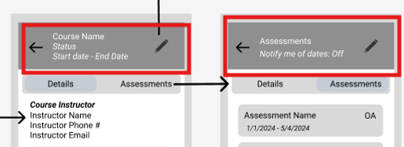
Internal Notification Menu was excluded: While an internal notification menu was included in the design, it was much simpler and more stable to make use of the android emulator’s built-in notifications swiping from the top of the screen.
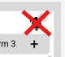
The order of the data displayed in the artificial header in the Detailed Course Information and Detailed Assessment information screens were slightly mutated to show the “Start” and “End” dates on top of one another. This was to fill the space to make the artificial header larger enough to feel natural.

A trash icon was added to the Detailed Course View: In order to give easier access to deleting courses, a trash icon was added in the view screen just below the edit pencil icon.


Notifications can be toggled for each assessment, instead of all or none: The ability to toggle notifications was expanded in the final result compared to the design. In the design, there is a single toggle to encompass both assessments. In the final, it was a better feature for the user experience to be able to toggle notifications one at a time.
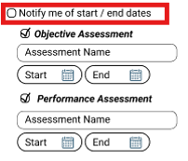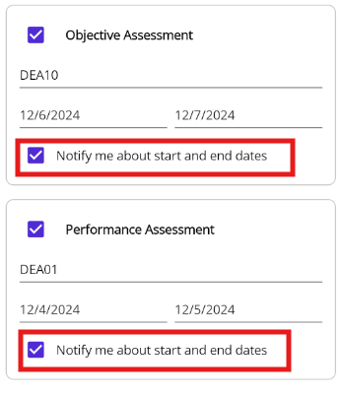
Part 2.
After the above mentioned changes, I certify that the final product vs design time designs match perfectly.

